Soccer Game Day Supervising To Do

Get money box, with programs & roster and drop off in Ticket Booth (block door or ensure ticket taker can get in)
Make sure baseball ramp gate is shut and locked
Turn on Football Lights when needed

Open South Round A bout Gate for officials to enter
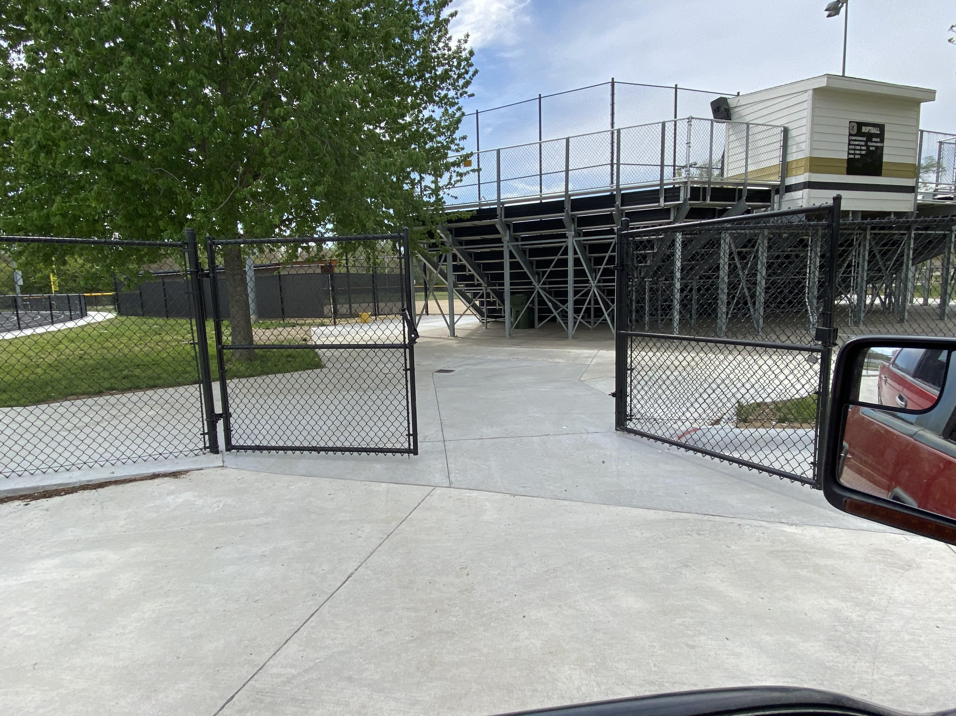
Open Track gate on south west side (turn 1) for officials to access game field
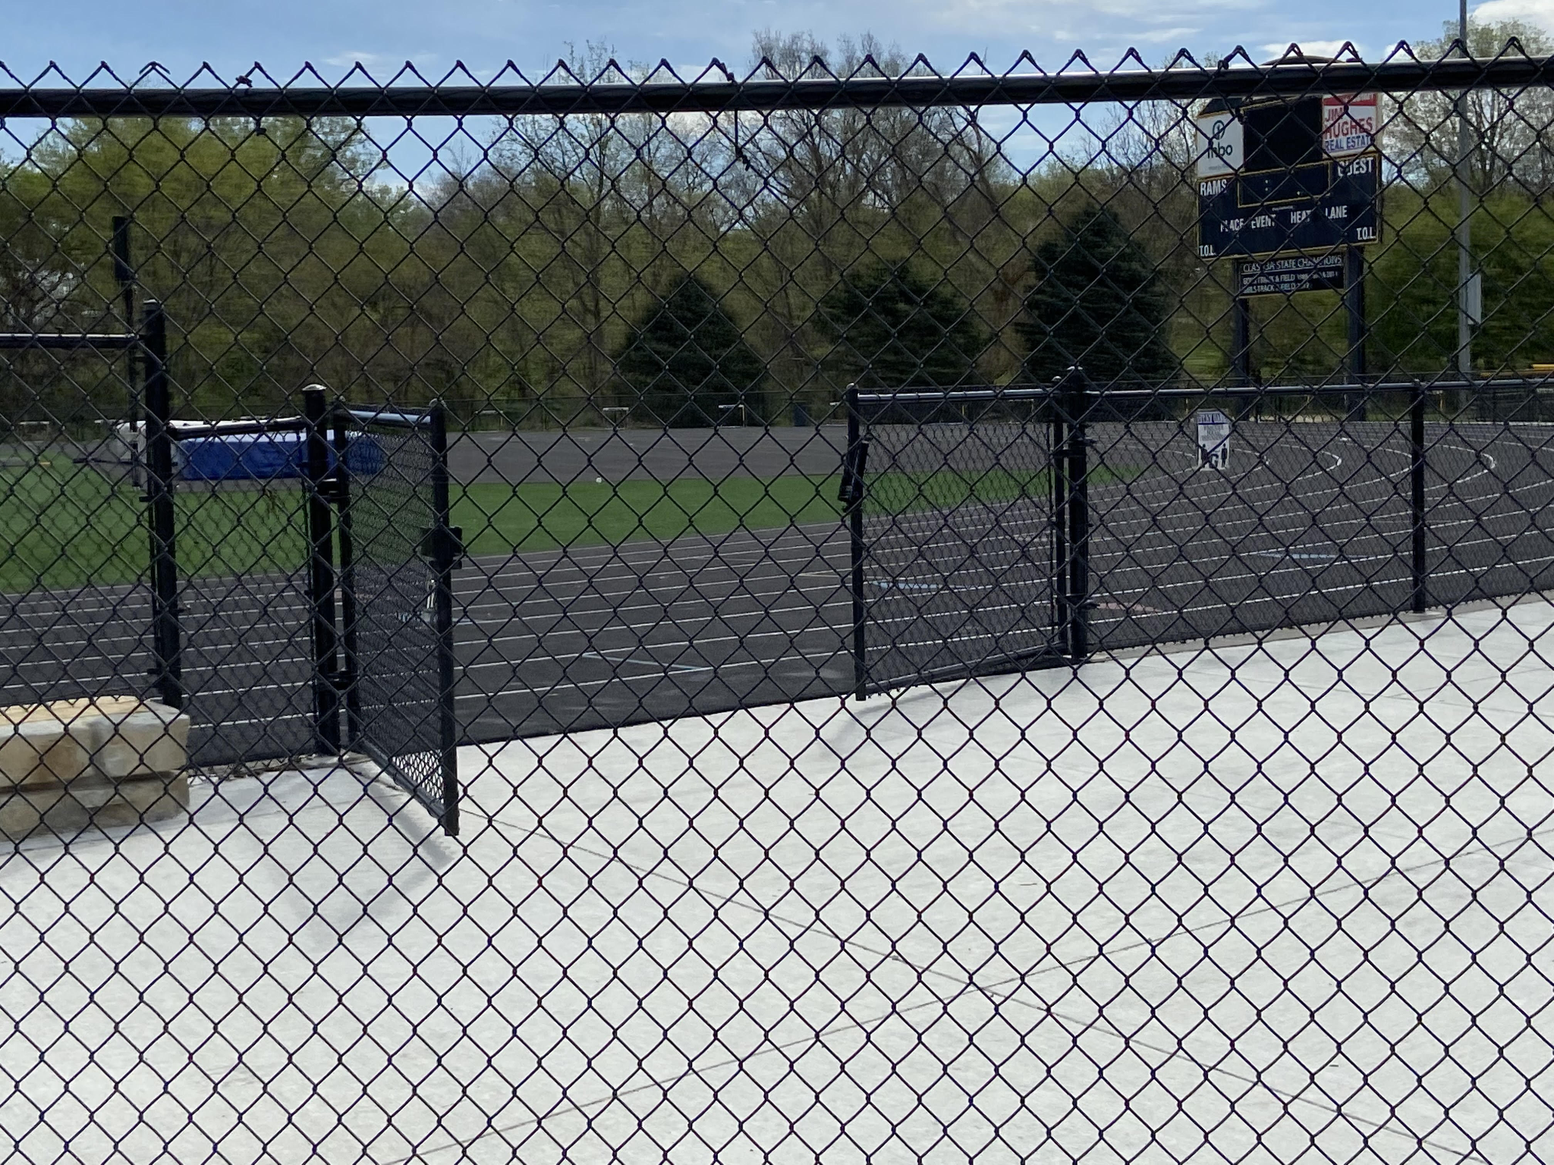
Open South gate (south of softball concession stand) for officials to access game field
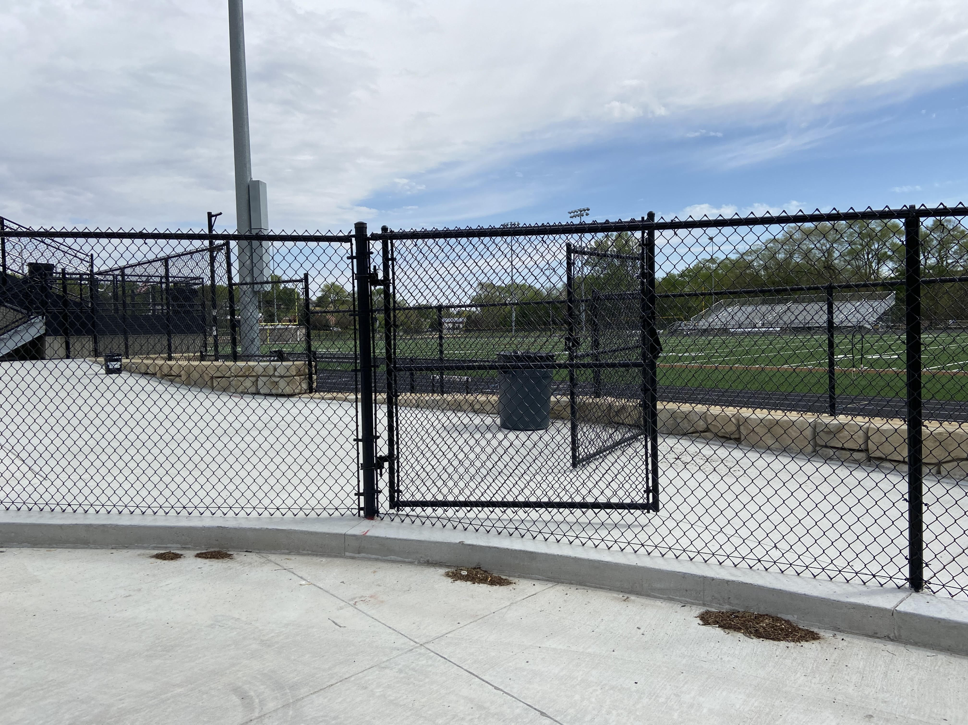

Set up 4 flags in the corners (in 3rd storage bay) (Use gator) if you desire)
Set up 1 flag with a water weight at mid field on home side where kids check in (in 3rd storage bay) (I left the yellow base and water weight at mid field so just need the flag)
Make sure team benches are off field on home side and under turf in lane 1
Make sure benches on visiting football side are as close to track as possible
Open room into elevator and make sure its dogged down (key in on top of door ledge leading into elevator) Picture below shows how to dog door down
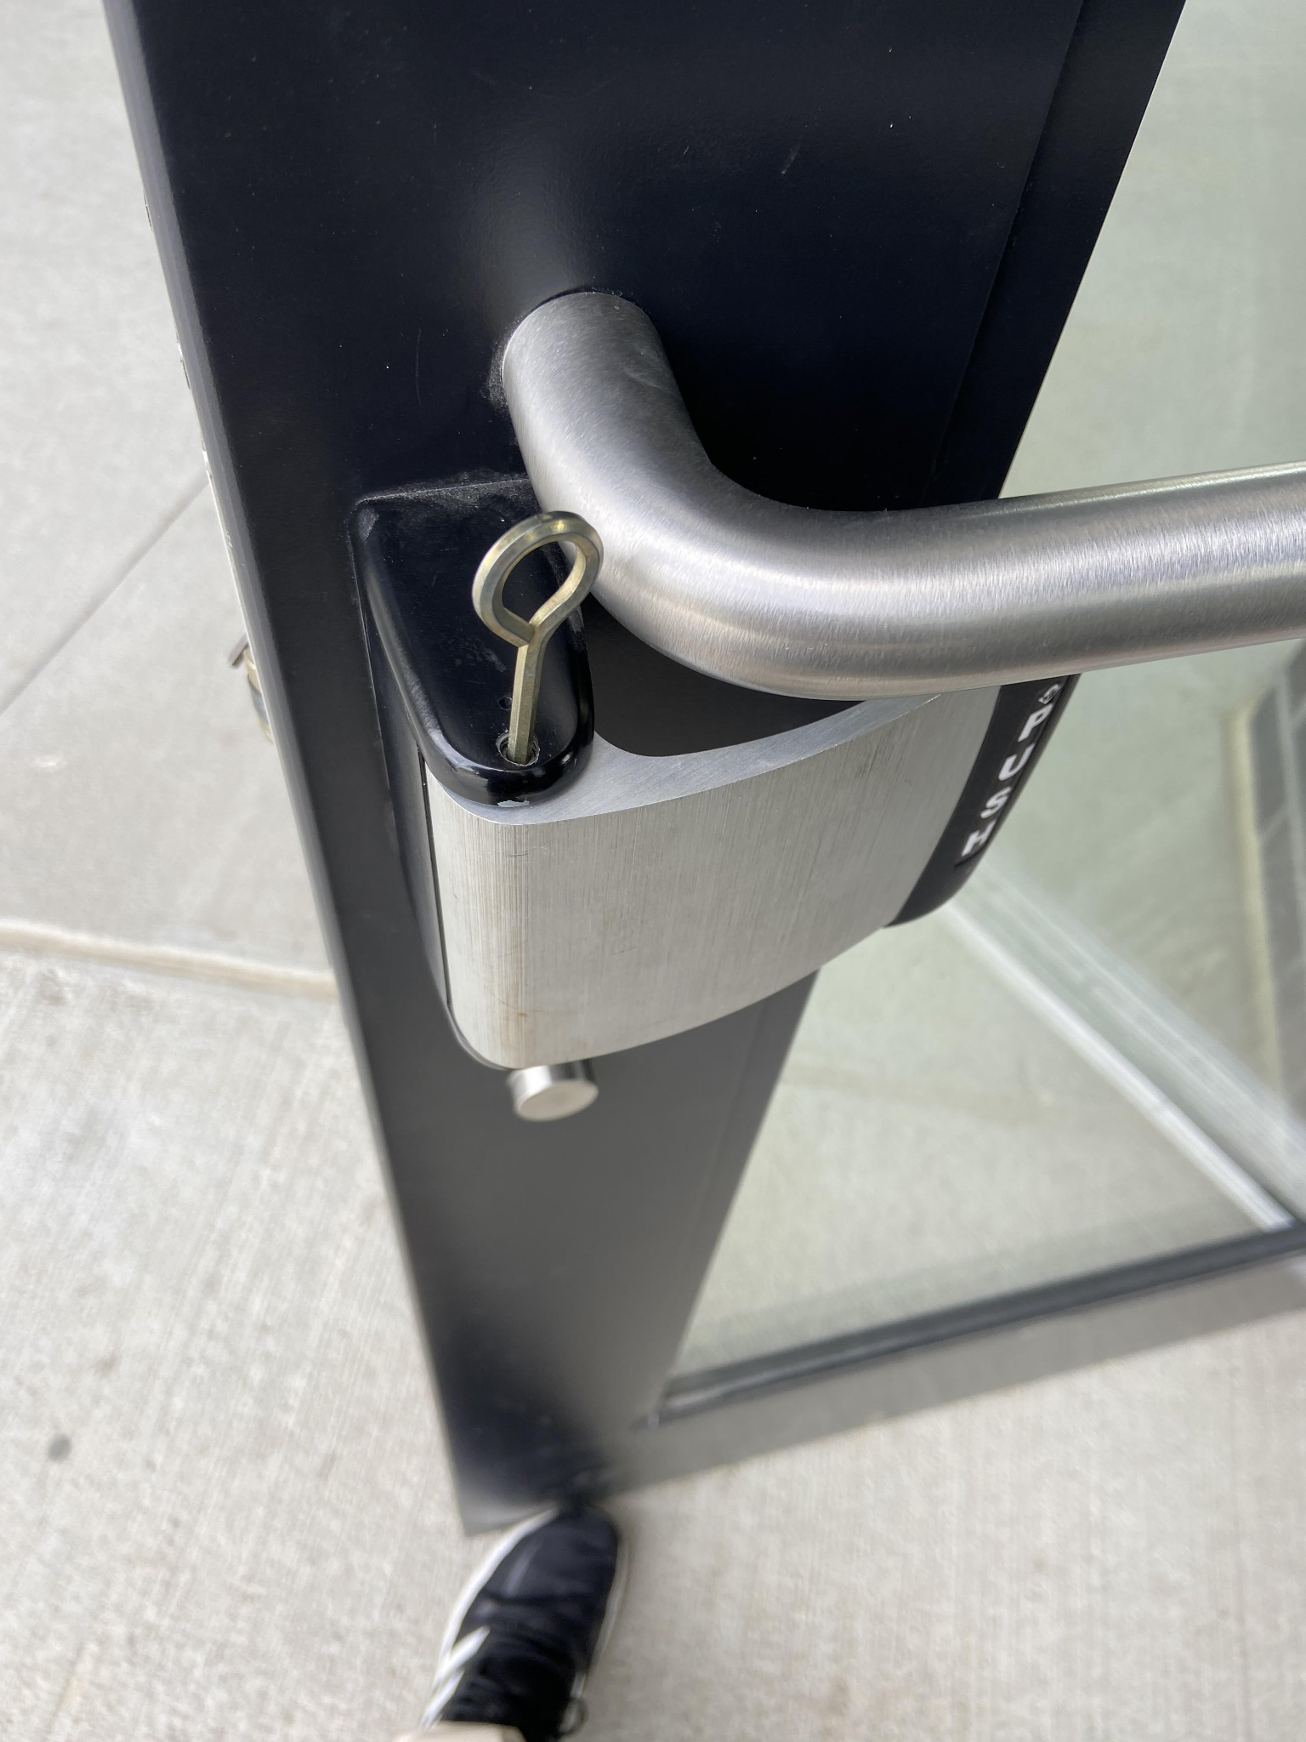

Take Statement of Claim forms to pressbox for officials to sign
Check Fridge to make sure candy bars and drinks are available for officials
Confirm laptop is ready for music and national anthem
Turn on laptop, click on neptune app, click on radio mode and music playlist has been set so should starting playing, adjust volume as needed.
Turn on clock and set clock to go off 4 minutes before game time
Check PA and make sure its at the volume of your choice
Get the starting line ups from both coaches

Running Scoreboard

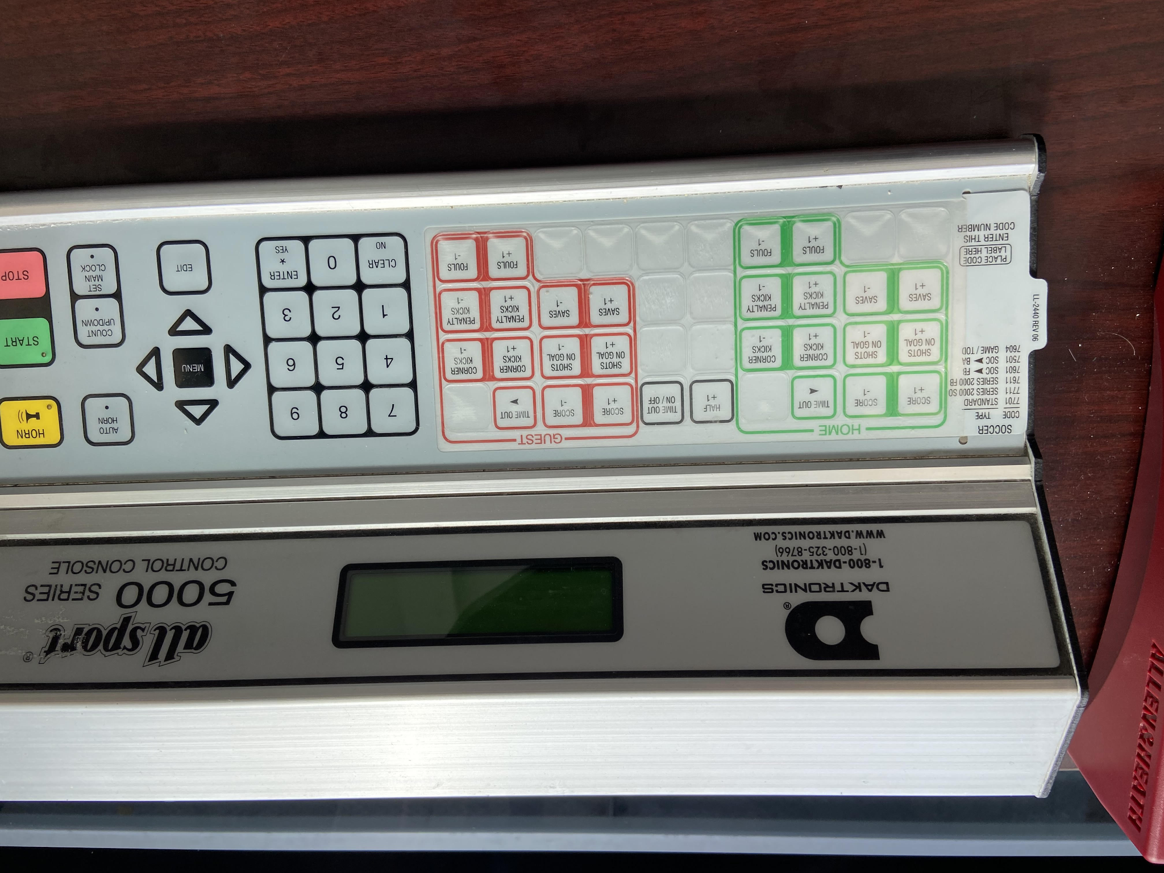

How to Run the Clock
Clock is in the pressbox
Turn on scoreboard on the back of the console on the table
It will ask if you want to resume game- Push NO
It will ask you to select code (soccer is 7701) hit enter (clock should show up on board)

Then make sure the timer toggle is turned to stop to enter new time.
Hit Set Main Clock (for varsity game it will be 40 minute halves)
Hit 4000 and then you have to hit enter. Clock should be set to 40:00.
Halftime is 10 minutes
You only stop the clock on goals, penalties and injuries (you can use the toggle switch or hit red stop button to stop) The referee should cross his wrists when to stop the clock.

If there is a score, push score +1 for the team that scored (home & away)

The refs have asked for a 2 minute warning on the PA....."2 minutes, 2 minutes remaining in the (1st/2nd) half"

Then you need to count down from 10.

Music
Black Neptune Lenovo computer is down there
Make sure power is plugged in and music aux cord is plugged in to it
Turn on computer (top right power button)
Make sure connected to internet
On desktop click on Neptune player
Should open to radio mode (if not click radio mode)
Click create new playlist
Select sport from drop down
Select music end time (set for 9pm)
Select auto populate (this could take a minute)
Set volume to desired level on computer as well as adjust on sound board if needed

For national anthem- click On Demand Mode
When ready-double click national anthem

If want music for later on, click back to radio mode

Power off when done

Good Evening Ladies and Gentlemen- Welcome to Glenwood for tonight's soccer game between the visitors on the scoreboard the ____________________& the home team on the scoreboard the Glenwood Rams.

Before the starting line up we would like to take a moment to promote good sportsmanship. It is a priority of the Iowa High School Athletic Association and The Glenwood High School that all participants and fans exhibit good sportsmanship. Your cooperation in role modeling sportsmanship will ensure that this contest displays the positive values of high school sports.
THANK YOU!

And now for the starting line ups first for the visiting ______________

The _______________ are coached by :

And now the starting line ups for your Glenwood Rams!

The Rams are coached by head coach

Your officials for tonight's contest are:

Now if everyone would please stand for the playing of the national anthem.

